**LAB 1**

**Theory**

Entity-Relationship (ER) diagrams are a vital tool in database design. They visually represent the data, relationships, and attributes within a system, providing a clear blueprint for constructing a database. In the context of a banking system, the ER diagram includes the following:

* **Entities**: Core components such as Bank, Bank Account, Customer, and Transaction represent real-world objects.
* **Attributes**: Each entity contains attributes that define its properties, such as Bank Name, Account Balance, Customer Details, and Transaction Details.
* **Relationships**: Interactions between entities are illustrated, for example:
  + A Bank owns multiple Bank Accounts.
  + A Customer may have multiple Bank Accounts.
  + Transactions are linked to Bank Accounts.

Create the ER-diagram of banking system having following entities:

* Bank
* Bank account
* Transaction
* Customer

Solution:

Step 1: The entities of the banking system are:

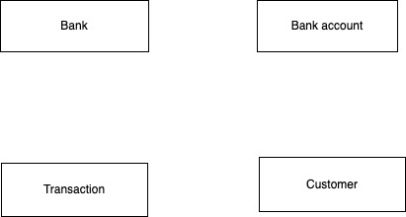

Step 2: The attributes of entities are as:

2.1. Bank: Name, City

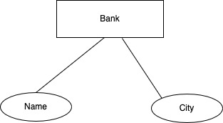

2.2. Bank account: Balance, Account holder, Bank

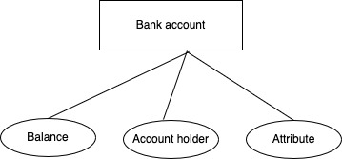

2.3 Customer: First Name, Last Name, Phone Number

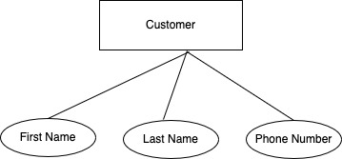

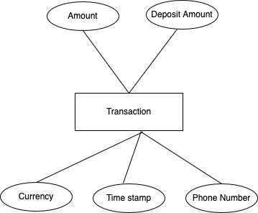2.4 Transaction: Deposit Account, Withdrawal Account, Timestamp, Currency, Amount

Step 3: Relationships:

* + - Bank Account is owned by a Customer.
    - Bank has a Bank Account.
    - Transaction is linked to the Bank Account.
    - The relationship between Bank Account and Customer is many to one because a Customer can have many Bank Account.
    - The relationship between Bank and Bank Account is one to many because a Bank can have many Bank Account.
    - The relationship between Transaction and Bank Account is many to one because multiple transaction can be linked to one Bank Account.

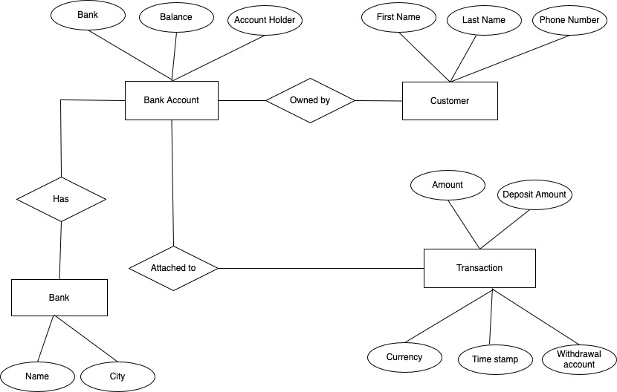

Figure 1: ER diagram of banking system

Conclusion: The ER diagram of the banking system was successfully created, demonstrating the relationships between entities, their attributes, and their connections. Through the creation of this diagram, a comprehensive understanding of the data structure and logical organization required for a banking database was established. This design was developed to ensure clarity, minimize redundancy, and lay the foundation for efficient database implementation.